Nihaal Sudhir Karhadkar , F009

SAP: 40772240009

 

Practical-1 Static code analysis using open source tool Flawfinder

Date:-12/07/2024 Submission Date:- 19/07/2024

Write-up:-

Static code Analysis & Benefits Vulnerability

Flawfinder

Implement static code analysis using open source tool Flawfinder for the following: Buffer overflow

String problem Race conditions,etc

Steps taken to perform the practical:

Download Flawfinder from Github

Using “pip install flawfinder” Install flawfinder using command prompt

Once flawfinder is installed we will test the given ‘test.c’ file given in the ‘test’ folder in the flawfinder folder.

Open command prompt and type “flawfinder test.c” It will run and give the following hits

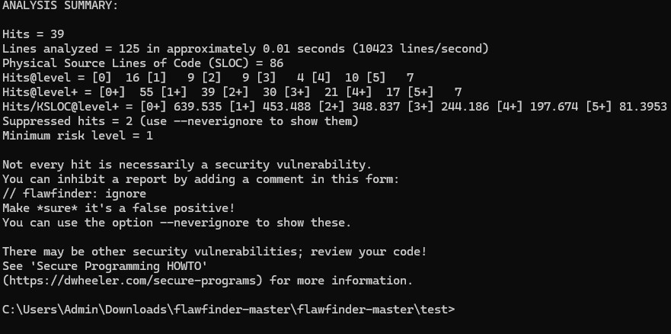

Created C Program to get array error

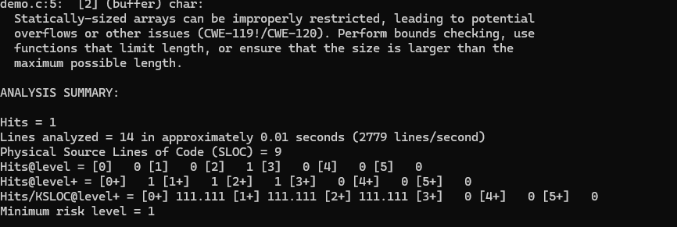

Created C Program to get race condition error:

Race Condition prac 1 paper 2 int main() {

char * fn = "/tmp/XYZ"; char buffer[60];

FILE *fp;

/* get user input */ scanf("%50s", buffer );

if(!access(fn, W_OK)){

fp = fopen(fn, "a+"); fwrite("\n", sizeof(char), 1, fp);

fwrite(buffer, sizeof(char), strlen(buffer), fp); fclose(fp);

}

else printf("No permission \n");

}

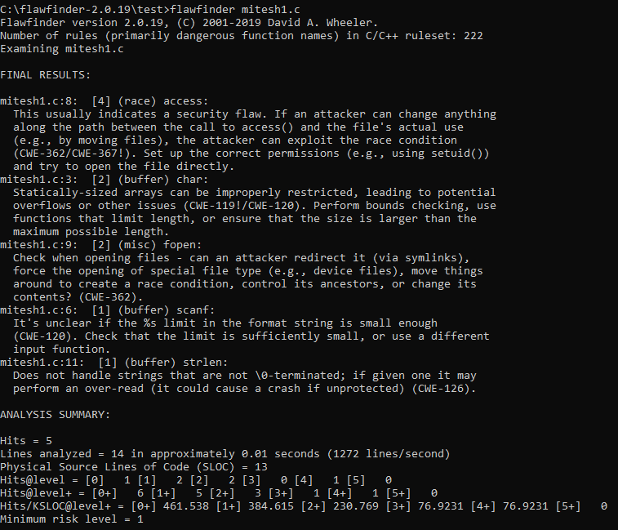

Created program to create buffer overflow error

// A C program to demonstrate buffer overflow #include <stdio.h>

#include <string.h> #include <stdlib.h>

int main(int argc, char *argv[])

{

// Reserve 5 byte of buffer plus the terminating NULL.

// should allocate 8 bytes = 2 double words,

// To overflow, need more than 8 bytes...

char buffer[5]; // If more than 8 characters input

// by user, there will be access

// violation, segmentation fault

// a prompt how to execute the program...

if (argc < 2)

{

printf("strcpy() NOT executed. \n");

printf("Syntax: %s <characters>\n", argv[0]); exit(0);

}

// copy the user input to mybuffer, without any

// bound checking a secure version is strcpy_s() strcpy(buffer, argv[1]);

printf("buffer content= %s\n", buffer);

// you may want to try strcpy_s() printf("strcpy() executed...\n");

return 0;

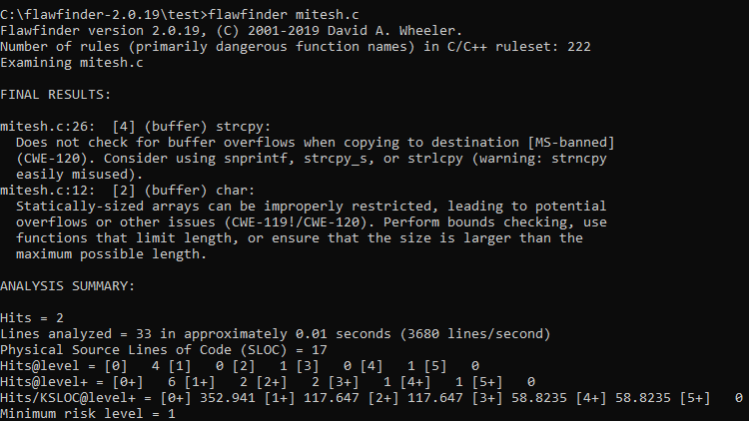

Created program to for string error #include <stdio.h>

#include <string.h>

int main() {

char buffer[5]; // Buffer to store strings (size 4 + 1 for null terminator)

char *fruits[] = {"apple", "banana", "mango", "carrot", "chikoo", "jackfruit"}; int i;

for (i = 0; i < sizeof(fruits) / sizeof(fruits[0]); i++) {

strncpy(buffer, fruits[i], sizeof(buffer) - 1); buffer[sizeof(buffer) - 1] = '\0'; // Ensure null-termination

printf("String %d: %s\n", i + 1, buffer);

// If the string is longer than the buffer, handle accordingly if (strlen(fruits[i]) > sizeof(buffer) - 1) {

printf("Warning: String '%s' truncated to fit buffer size.\n", fruits[i]);

}

}

return 0;

}

